**MSSQL Server Database Migration To New Stand-Alone or Primary Server Using BACKUP & RESTORE Method**

This document contains the step-by-step task required to create a replica of a Microsoft SQL Server database on a different instance.

The overall tasks for standalone or PRIMARY servers are:

1. **Check the disk space allocation on the source server.**
   1. Log into the source server and navigate to Computer Management. 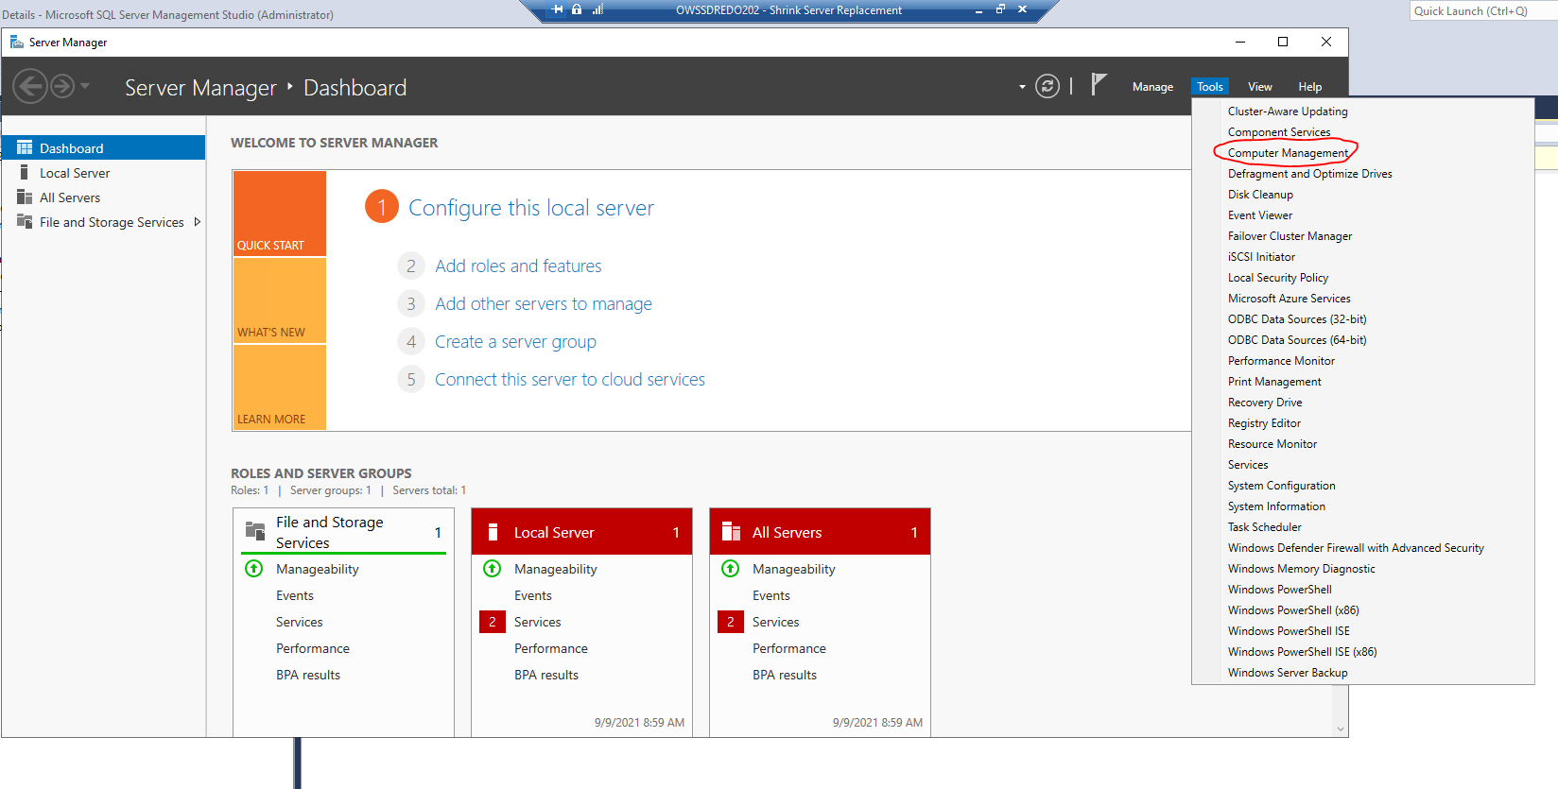
   2. Navigate to Disk Management and take a screenshot of the Volume list. This will be used to ensure the target server has sufficient space to hold the databases.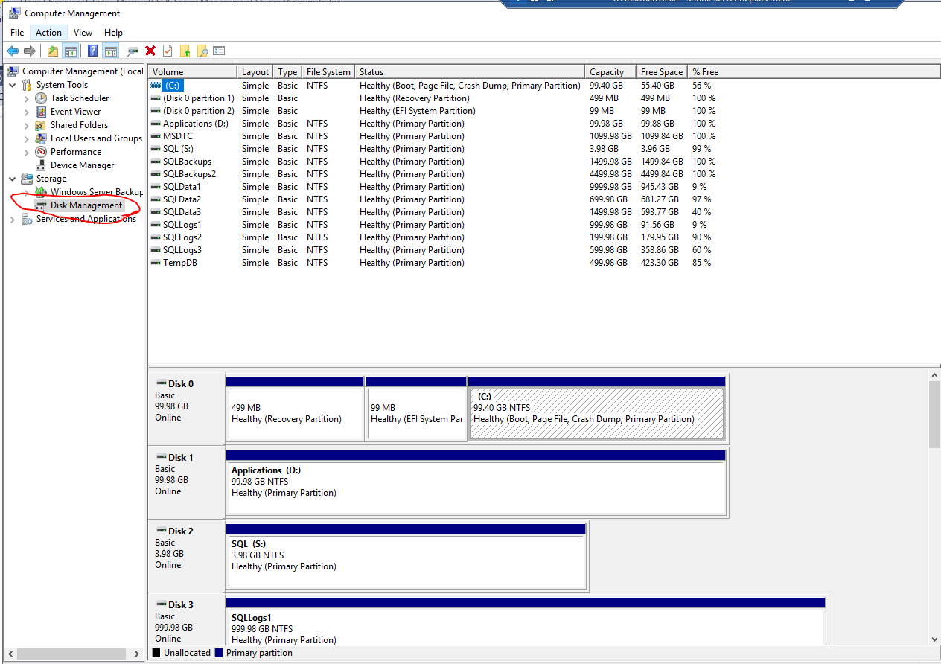
2. **Create the target directories for the database files.**
   1. The two text files containing the commands to create the necessary directiories are located here: \\RWSQLMGMTH202\c$\PowerSh\Rollins\DBA_Admin\database transfer\Transfer DBs to New Server
      1. Create_System_Db_Directories.txt
      2. Create_User_Db_Directories.txt
   2. Open a COMMAND prompt on the new server, paste the commands and hit ENTER.
3. **Backup the target databases.**
   1. Open your desired tool for creating database backups.
   2. Choose a location for the backup file that will be accessible by the target server.
      1. When using the MSSQL native backup method, choose a shared network directory that can be reached by the other server(s).
         1. Make sure the directory is large enough to hold the file. If it isn’t, contact the appropriate department to request more space.
      2. Third-party tools, such as EMC’s DDBoost, use a shared backup server, so space and accessibility shouldn’t be an issue.
   3. Give the file a descriptive name that is easily identifiable.
   4. Choose the FULL & COPY-ONLY options.
   5. Set the retention period to an acceptable, realistic value; you don’t need to keep this backup after the next regularly scheduled full backup.
4. **Restore the database(s) onto the target standalone or PRIMARY server/instance.**
   1. Once the backup has completed, log into the target server and **REPEAT STEP 1, A & B FROM ABOVE.**
   2. Compare the Volume sizes of the source and target.
      1. Ideally, these values will be exactly the same, including the names. If not, you can use the MOVE option in the database restore to place the files in their proper location on the target server.
   3. Open the backup utility and navigate to the RESTORE portion.
      1. Locate the backup previously created in **Step 2**.
      2. Follow the necessary steps for restoring your database(s)
         1. Set the proper locations for each file using the standard path & naming convention.
            1. For example, new DEV boxes will store data files in C:\SQLMounts\Data2\SQLdata1\<__Database Name__> 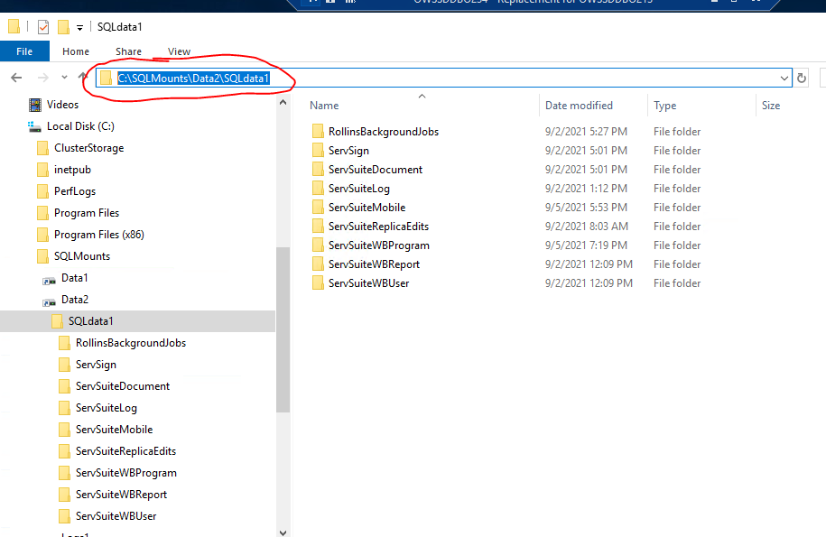
      3. For the standalone or designated PRIMARY target server chose the “WITH RECOVERY” option for the restore.
   4. Once the restore has completed, execute the scripts to create the logins, passwords, database mappings and ownership from the original server.
5. **Copy the logins, passwords, and database permissions from the source database.**

Repeat these steps after all databases have been restored on each server.

The scripts 01_Create_procs_to_transfer_logins_to_new_server.sql and 02_Generate SQL_For_Logins.sql are used to generate the scripts that will be used to recreate the users on the target MSSQL Server instance.

* 1. Copy the files to a location accessible by the source/original server.
     1. On the source/original server, execute the script 01_Create_procs_to_transfer_logins_to_new_server.sql
     2. Copy the contents of the “**Messages**” tab to a **new query window on the new target server** and execute.
     3. On the source/original server, execute the script 02_Generate SQL_For_Logins.sql
     4. Copy the contents of the “**Results**” tab to a **new query window on the new target server** and execute.
     5. All logins from the source server have been created on the new server with their existing hashed passwords.
  2. Verify that all restored databases are accessible and all users have been recreated.

If this is an Always-On configuration, proceed to the document **MSSQL Server Create Databases On A Replica Server Using BACKUP & RESTORE Method** for instructions on setting up the replicas.